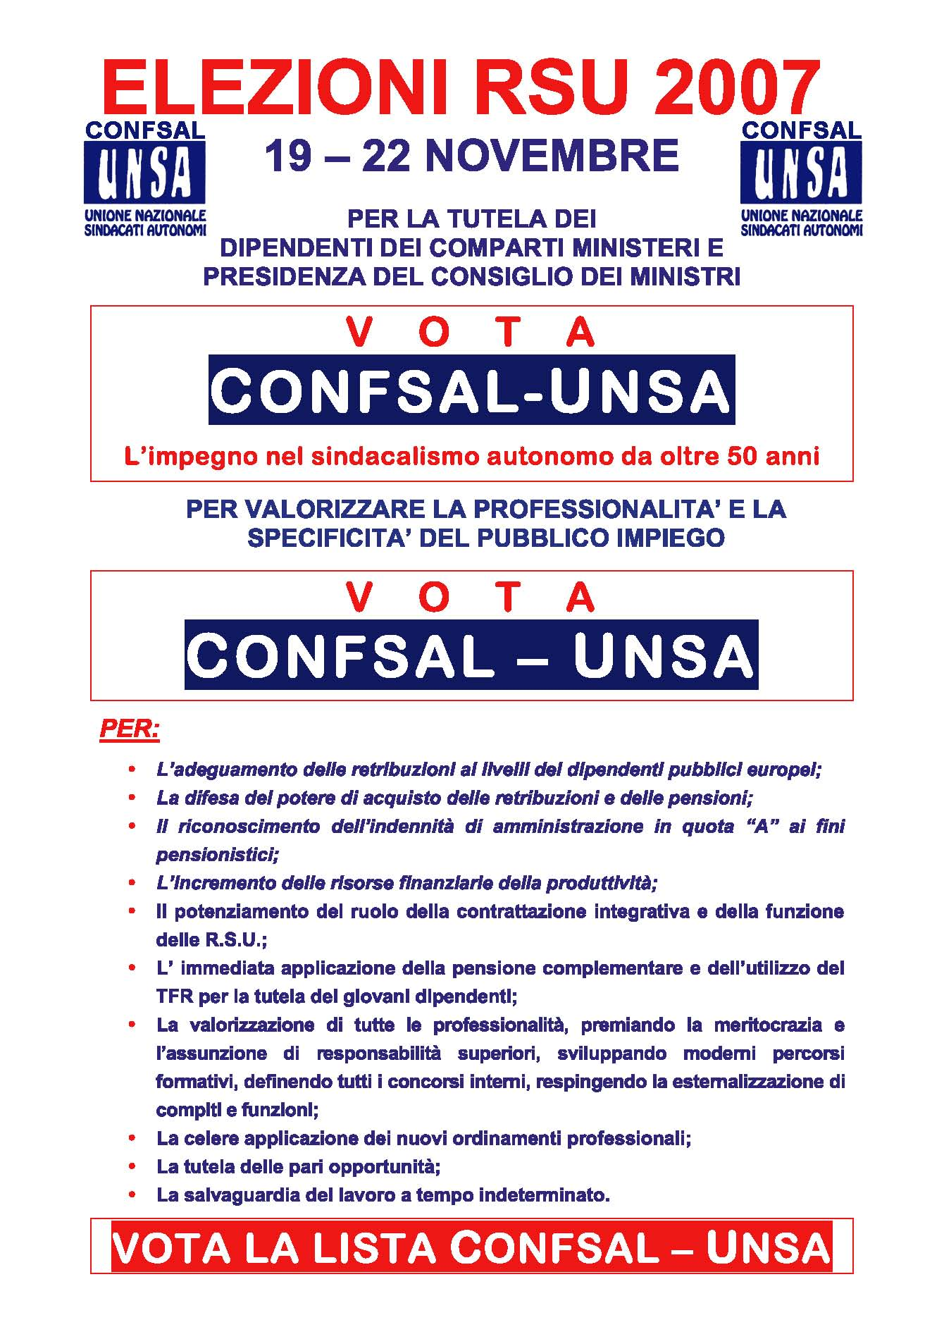
PRESSO L’ENTE _____________________________________________________________

I CANDIDATI CONFSAL – UNSA
________________________________ ______________________________

________________________________ ______________________________

______________________ ____________________________





